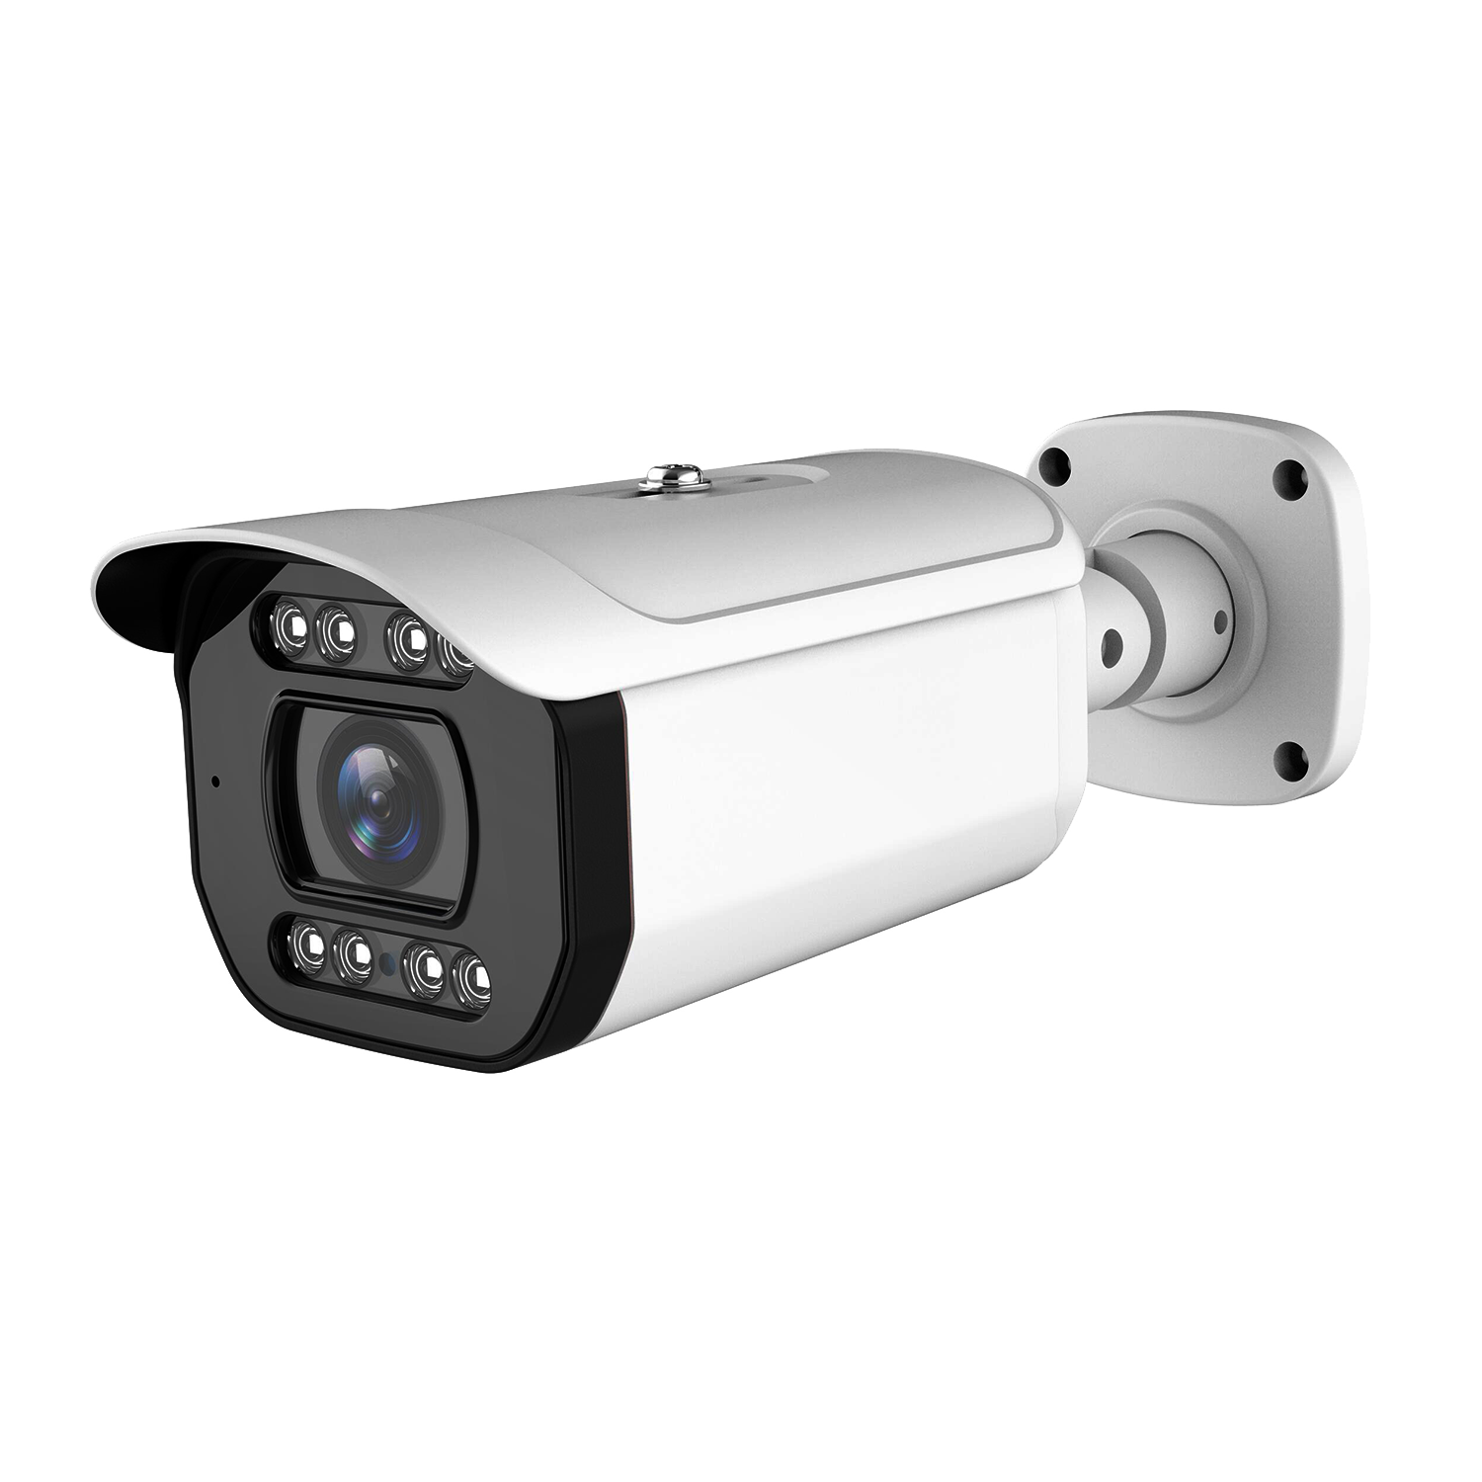


NST-IPN5134-ANPR
4MP Network IR Water-Proof
Bullet Camera
H.265+ / H.265 / H.264+ / H.264 / MJPEG Max . resolution: 2560 × 1440  Starlight  ICR auto switch , true day / night vision  50~70m IR night view distance; motorized zoom lens  3D DNR, true WDR, HLC , BLC , Defog , Smart IR and ROI coding Built-in micro SD card slot; up to 256GB  AC24V/DC12V/PoE power supply  IP 67 ingress protection Support three streams  Support remote monitoring by smart phones & tablet PCs with iOS and Android OS  AI function secondary development supported |  |  | H.265 |  | Day&Night |  | WDR | AWB |   Defog | HLC
  H.265
 |  |  |  |  |  |  | PoE | 
BLC Motion PoE IP67 VCA -30° ~60°
Detection

4MP Network IR Water-Proof Bullet ANPR Camera
NST-IPN5134-ANPR
SPECIFICATIONS

PoE | Yes , IEEE802 .3af
IR Distance | 50 ~ 70 m
Ingress Protection | IP 67
Others
Power Supply | AC24V/DC12V/PoE
Power Consumption | < 12 .5W
Storage Conditions | - 30 °C ~ 65 °C (-22 °F~ 149 °F) , Humidity: less than 95 % (non-condensing)
Operating Conditions | - 30 °C ~ 60 °C (-22 °F~ 140 °F) , Humidity: less than 95 % (non-condensing)
Dimensions ( mm ) | 278.3 × 100 .2 × 88 .7
Weight ( net ) | Approx . 1 .04KG
Installation | Ceiling mounting; Wall mounting
Certificate | CE , FCC
Environmental Protection | Directive EU RoHS , WEEE(2012/19/EU) , directive 94/62/EC and REACH(EC1907/2006)

Model Specifications | NST-IPN5184-ANPR
Camera
Image Sensor | 1 / 1 .8 "CMOS
Image Size | 2560 × 1440
Electronic Shutter | Auto/manual; Manual mode: 1 /3s ~ 1 / 100000 s
Iris Type | P-Iris
Min . Illumination | 0 .0014 lux@F1 .5 ,AGC ON;  0 lux with IR
Lens | 8~ 32mm@F1 .5 , motorized
Field of View | Horizontal：109°~46°; vertical: 74 .5°~27 . 1°; diagonal: 116°~52 .4°
Lens Mount | Φ14
Day & Night | ICR
Wide Dynamic Range | 120dB
BLC | Yes
HLC | Yes
Defog | Yes
Digital NR | 3D DNR
S/N Ratio | ≥50dB
Angle Adjustment | Pan: 0°~360°; Tilt:0°~90°; Rotation: 0°~360°
Image
Video Compression | Main stream: H.265+ / H.265 / H.264+ / H.264  Sub stream: H.265+ / H.265 / H.264+ / H.264 / MJPEG  Third stream: H.265+ / H.265 / H.264+ / H.264 / MJPEG
H.264 Compression Standard | Baseline Profile/Main Profile/High Profile
Resolution | 4MP ( 2560 × 1440 ) , 3MP ( 2304 × 1296 ) , 1080P ( 1920 × 1080 ) , 720P ( 1280 × 720 ) , D1 , VGA(640 × 480) , 480 × 240 , CIF
Main Stream | 4MP/3MP/1080P / 720P( 60Hz : 1 ~ 30fps; 50Hz: 1~25fps )
Sub Stream | 720P/D1/CIF/VGA/480×240 ( 60Hz : 1 ~ 30fps; 50Hz: 1~25fps )
Third Stream | D1/CIF/480×240 ( 60Hz : 1 ~ 30fps; 50Hz: 1~25fps )
Bit Rate | 64 Kbps ~ 8 Mbps
Bit Rate Type | VBR / CBR
Audio Compression | G711A / U
Image Settings | ROI , Saturation , Brightness , Hue , Contrast, Wide Dynamic , Sharpness , Image Mirror, Image Flip , NR, etc . adjustable through client software or web browser
ROI | Each ROI to be configured separately
Interfaces
Network | RJ 45 10M/100M self-adaptive Ethernet port
Video Output | CVBS output (BNC × 1)
Audio | 1CH audio input; 1CH audio output
Storage | Built-in micro SD card slot; up to 256GB
Reset | Yes
Alarm | 1CH alarm input; 1CH alarm output
Functions
Remote Monitoring | Web Browser/VMS2 .0/NVR/mobile APP
Web Browser | IE11(plug-in required)/Chrome 89 .0+/Edge 89.0+/Firefox 87.0+/Safari 14 .0+
Online Connection | Support simultaneous monitoring for up to 10 users; Support multi-stream real time transmission
Network Protocol | UDP, IPv4 , IPv6 , DHCP, NTP, RTSP, RTP, RTMP, RTCP, PPPoE , DDNS , SMTP, FTP, SNMP,HTTP, 802.1x, UPnP, HTTPS , HTTP POST, QoS
Interface Protocol | ONVIF
Storage | Network remote storage; micro SD card storage
Smart Alarm | Motion detection , sensor detection , SD card error, SD card full , IP address conflict , cable disconnection
Intelligent Analytics | Self-defined
General Function | Watermark, video mask, heartbeat , corridor pattern
Security | Video encryption, firmware encryption, HTTPS encryption, configuration encryption , illegal login lock, IP address filtering , 802 . 1x authentication , basic and digest authentication for HTTP/HTTPS

